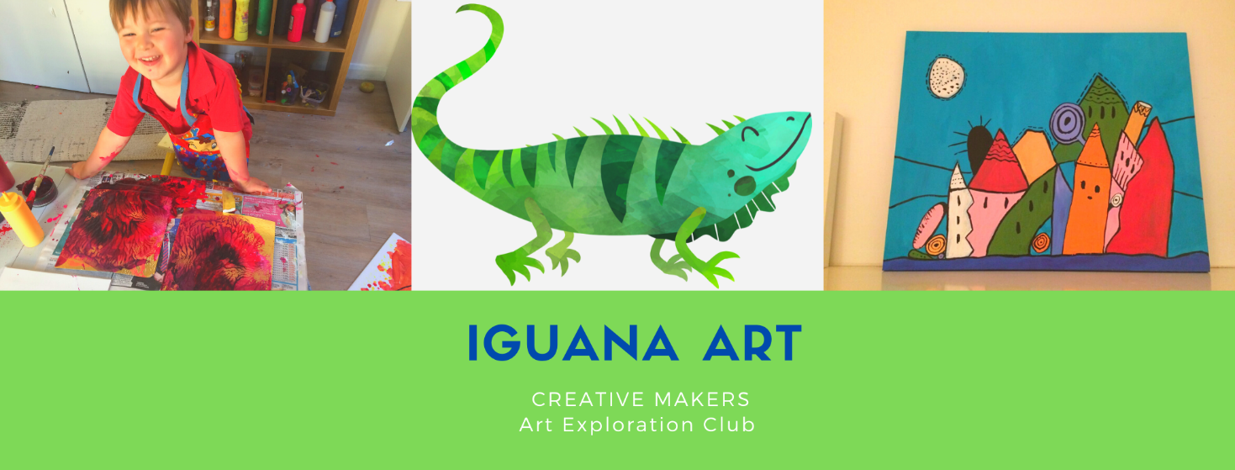

Lavender Lodge,
Main Rd, Colwich
ST17 0XE
T.07962303937

21 September 2021

Dear Parents,
Thank you for getting in touch and enrolling your child onto the 4 week After School Art Club at Chadsmead Primary Academy starting on Tuesday 5 October from 3.30-4.30pm. Please make sure your child wears appropriate clothing for painting and creative activities. (If you could send an old shirt with long sleeves to cover their arms). We will provide an apron which provides coverage.
Many thanks,

Emma Wood B.A Hons

Measures to Keep Your Child Safe:
● Each child is allocated their own materials to use during the session.

Ensure your child arrives and is collected at the correct time.

- Follow current government guidelines regarding social distancing as you wait for your child.
- Drinks bottles will be allowed and will be kept on each child’s table.
- Follow government guidance on staying safe. If your child displays any symptoms of illness, (not just Covid 19 specific), please do not attend.
- Children are welcome to bring in a snack. (There will be a short break in the middle of the class)
- Children shouldn’t come in if they are displaying any of the following:
- Temperature above 37.7C
- Cough
- Stomach upset/pain
- Vomiting
- Diarrhoea
- Eye infection
- Headache
- Cold or flu-like symptoms, (sneezing, runny nose, etc.).

Please ask you child to agree to the following:

- I will help keep everyone safe by following all instructions given by the art teacher.
- I will do my best to maintain social distancing.
- I will clean my hands with soap and water or sanitiser
- On arrival
- After the break
- Before eating
- After using the toilet
- Before leaving

Child’s name:
Date of birth:
Address:

Date of classes: 5,12,19 October and 2 November 2021
Times booked: 3.30-4.30pm

Home Phone Number:
Mother’s name:
Contact number:
Work:
Mobile:

Father’s name:
Contact number:
Work:
Mobile:
Any medical conditions?

Any Allergies?
Photography consent ?

In the event of a session being cancelled, another session will be offered in lieu.

Parent’s signature:

Date:

